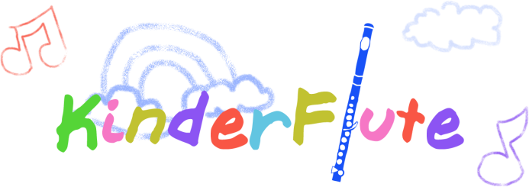
Academy
Lesson Policy
Goals and Expectations: The goal of Kinderflute lessons is to provide flute and music instruction to your child in a fun and individualized way. Each child learns at their own pace, and regular attendance and commitment to lessons is essential. Please review the requirements below and provide your signature to signify your commitment:
Scheduling:
___Instructor Cancellations- In the event that the instructor has to suddenly cancel a lesson, the student has a choice of making up the lesson or subtracting the cost of the missed lesson to the next month’s fees.
___Student Cancellations- If a student cancels a lesson, please call, email and notify the agency where the lesson is held. Students should give advance notice (30 days is helpful) of planned absences. Lessons can be made up only if there is a time slot available within two weeks, or on Skype.
___Email notifications-It is important to check your emails every weekend. The instructor sends out a calendar reminder on Saturday or Sunday of each week with a reminder of upcoming lessons. Always check and make sure your time slot is accurate and notify the instructor immediately if there are any errors.
___No shows- If a student misses more than two weeks in a row without notifying the instructor, the student loses his/her time slot.
___Lateness- If a student is more than 15 minutes late, the instructor may cancel the lesson due to time constraints and the lesson will not be made up or refunded.

Payment
___Tuition-Payment for one month of lessons is due on the week proceeding the following month of lessons. Payment is either for four or five lessons, depending on the duration of the month. Checks are made payable to the instructor, Molly Shortridge.
___Initial lesson- If the student’s initial lesson is in the second, third or fourth week, pay for only the initial lesson plus the remaining lessons of that month.
___Holidays- Some months have fewer lessons due to holidays, instructor’s vacation, or the instructor’s performance schedule. The instructor will communicate in advance the number of lessons for that month, or attempt to arrange a different time slot to make up a lesson.
___Termination- There is no refunds if the student quits in the middle of the month. Advanced notice shall be given (30 days is helpful), in the event of the student needing to terminate.

Practice Requirements:
__Daily practice is necessary to achieve a good sound on the flute and become proficient
__Beginners start with 15 minutes per day and progress gradually towards more minutes as they become proficient
__Parents should be aware that children often begin to resist practicing within the first month or two, and that a program of regular practice with incentives is often necessary. The rewards are great and practicing gets easier as they age.
__It is sometimes helpful to have focused practice in small doses, with 10-20 minute time slots interspersed with other activities, such as exercise, family interactions and chores
__Practicing also means listening and other activities. The instructor recommends that students spend some focused time listening to great performers on the flute on recordings or YouTube. Listening to a variety of genres of music and other instruments is quite helpful, as well.
___It is helpful to have the following tools at home:
- Music stand
- Metronome
- Tuner
- Recording device that the student can operate (such as on an ipod, digital recorder, camera)
- Pneumo-pro wind director or other helpful tools

Lesson Requirements:
___Lessons are weekly and each individual student is schedule for one time slot.
___The parent is welcome to attend the beginner lessons. It is often necessary if your child is very young to attend the lessons, so that the parent knows how to help with home practice.
___It is very helpful for the student to bring the following materials to the lesson:
- Instrument
- Recording device that the student can operate (such as on an ipod, digital recorder, camera)
- Notebook
- Music books and music
- Pneumo-pro wind director or other tools the teacher suggests

Please make sure you have read the policy. Place a check mark next to each item above to indicate you have read each item. Discuss with the instructor any concerns you might have. Regular communication with the instructor is often the best way to resolve any issues, and very much helpful for a successful experience. Sign below if you agree to the above policy.
Parent____________________________________________________ Date________________

Student___________________________________________________ Date________________

Instructor__________________________________________________ Date _______________

