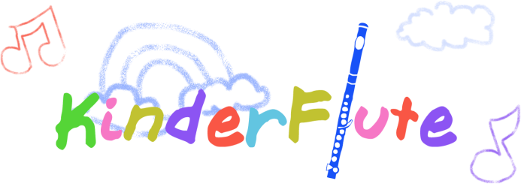
Academy
Group Class Policy
Goals and Expectations: The goal of Kinderflute classes is to provide flute and music activities and games that require interactions with peers and the Instructor. Classes are expected to be ongoing, with breaks between semesters. As a part of these classes, children begin to participate in ensembles that help solidify the concepts of cooperation, tuning, listening, musicianship, leadership and the ability to follow. Cooperative activities are important for later success in music. The instructor is aware that each child learns at their own pace and the weekly lessons are required for students in each class, so that individualized training can begin. Regular attendance and commitment to bot the group classes and private lessons is essential. Please review the requirements below and provide your signature to signify your commitment:
Scheduling:
___Instructor Cancellations- In the event that the instructor has to suddenly cancel a class, the class date will be extended into the week following the last scheduled class for that semester. If the student is unable to attend the make-up class, the cost of the missed lesson will be refunded. This is also the case if a class is cancelled due to weather.
___Student Cancellations- If a student cancels a class, please call, email and notify the agency where the class is held. Students should give advance notice (30 days is helpful) of planned absences.
___Email notifications-It is important to check your emails every weekend. The instructor sends out a calendar reminder on Saturday or Sunday of each week with a reminder of upcoming classes and lessons. Always check and make sure your time slot is accurate and notify the instructor immediately if there are any errors.
___No shows- If a student misses more than two weeks in a row without notifying the instructor, the student loses his/her time slot.
___Lateness- If a student is more than 15 minutes late, the instructor may cancel the lesson due to time constraints and the lesson will not be made up or refunded.

Payment
___Tuition-Payment for one semester of lessons is due at the beginning of the class. Paying ahead reserves space for your child.
___Holidays- Some months have conflicting holidays, instructor’s vacation, or the instructor’s performance schedule. The class schedule is posted prior to the start of each semester.
___Termination- There is no refund if the student quits in the middle.

Practice Requirements:
__Daily practice is necessary to achieve a good sound on the flute and become proficient
__Beginners start with 15 minutes per day and progress gradually towards more minutes as they become proficient
__Parents should be aware that children often begin to resist practicing within the first month or two, and that a program of regular practice with incentives is often necessary. The rewards are great and practicing gets easier as they age.
__It is sometimes helpful to have focused practice in small doses, with 10-20 minute time slots interspersed with other activities, such as exercise, family interactions and chores
__Practicing also means listening and other activities. The instructor recommends that students spend some focused time listening to great performers on the flute on recordings or YouTube. Listening to a variety of genres of music and other instruments is quite helpful, as well.
___It is helpful to have the following tools at home:
- Music stand
- Flute (curved head joints best for beginners)
- Metronome
- Tuner
- Recording device that the student can operate (such as on an ipod, digital recorder, camera)
- Pneumo-pro wind director or other helpful tools

Class Requirements:
___Classes are weekly and each individual student is schedule for one time slot.
___Weekly private lesson are a requirement of being a part of the class. The child will attend two activities each week: Group Kinderflute™ lessons and a 30 minute private lesson. Private lessons are not included in the price of the class, and are an additional charge (payment due monthly).
___It is very important that parents are involved by observing the class, so that the parent knows how to help with home practice.
___It is very helpful for the student to bring the following materials to the class:
- Flute (by the third class)
- Recording device that the student can operate (such as on an ipod, digital recorder, camera)
- Music books and music
- Pneumo-pro wind director or other tools the teacher suggests

Please make sure you have read the policy. Place a check mark next to each item above to indicate you have read each item. Discuss with the instructor any concerns you might have. Regular communication with the instructor is often the best way to resolve any issues, and very much helpful for a successful experience. Sign below if you agree to the above policy.
Parent____________________________________________________ Date________________

Student___________________________________________________ Date________________

Instructor__________________________________________________ Date _______________

