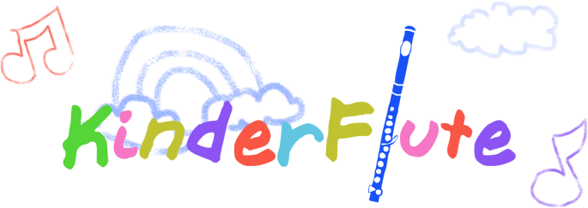
KinderFlute Academy Registration and/or Mailing List for Future Info

Student’s name____________________________________________ Age _______

Parents’ names___________________________________________________

Address ________________________________________________________

Email _________________________________________________________

Phone _________________________________________________________

Student’s interests and hobbies______________________________________

Yes I would like to sign-up for KinderFlute Classes and lessons.

Yes I would like to sign-up for private KinderFlute lessons and not a Kinder Flute Class.

No We are not interested in taking KinderFlute Classes right now, but please keep us informed of future classes.
Contact: Molly Shortridge mollysflutes@verizon.net www.KinderFlute-Academy.com

